SIMATS ENGINEERING
ASSESSMENT TOOL 1

COURSE NAME: CSA0404
COURSE CODE: Operating Systems

COURSE OUTCOME COVERED

CO4: Optimize various file allocation strategies and disk scheduling algorithms to identify optimal methods for enhancing system performance.

Assessment Tool Weightage: 40%

QUESTIONS: 5 Total Marks:25

Annexure A

CODING CHALLENGE/HACKATHON

Code of Conduct:

I _KAVINILAVU.S(192565038)_ (Name / Reg No) certify that this submission is my original work and that I have adhered to the guidelines specified for this assessment.
I understand that any violation of academic integrity rules will result in disciplinary action.

Signature of the student:

KAVINILAVU.S

Annexure A

CODING CHALLENGE

Question 1

Write a program to simulate the three file allocation methods—Contiguous, Linked, and Indexed. The program should accept inputs including the total disk size (number of blocks), the file size(number of blocks required),and the allocation method (1forContiguous, 2for Linked, 3 for Indexed). Based on the selected method, the program must allocate disk blocks accordingly, display the allocated block numbers, and handle fragmentation scenarios, particularly when contiguous allocation fails due to insufficient continuous space. The output should show the list of allocated blocks or an appropriate error message if allocation is not possible. Ensure that built-in memory allocation functions are not used, and assume that disk blocks are numbered starting from 0.

Aim
To implement and simulate Contiguous, Linked, and Indexed file allocation methods in C.

Algorithm
Contiguous Allocation
- Read the number of disk blocks and required file size.
- Search for consecutive free blocks.
- If enough consecutive blocks are available, allocate them.
- Otherwise, display an allocation failure message.
Linked Allocation
- Search for free blocks anywhere on the disk.
- Allocate the required number of free blocks.
- Display the blocks in linked order.
Indexed Allocation
- Allocate one free block as the index block.
- Allocate the required number of additional free blocks.
- Display the index block and data blocks.

C Program
#include <stdio.h>

int main() {
int disk[100], n, fileSize, choice;
int i, j, start = -1, count;

printf("Enter total number of disk blocks: ");
scanf("%d", &n);

if (n <= 0 || n > 100) {
printf("Invalid disk size.\n");
return 0;
}

printf("Enter initial disk status (0-Free, 1-Allocated):\n");
for (i = 0; i < n; i++) {
scanf("%d", &disk[i]);
}

printf("Enter file size in blocks: ");
scanf("%d", &fileSize);

if (fileSize <= 0 || fileSize > n) {
printf("Invalid file size.\n");
return 0;
}

printf("\n1. Contiguous Allocation");
printf("\n2. Linked Allocation");
printf("\n3. Indexed Allocation");
printf("\nEnter your choice: ");
scanf("%d", &choice);

/* Contiguous Allocation */
if (choice == 1) {
for (i = 0; i <= n - fileSize; i++) {
if (disk[i] == 0) {
count = 0;

for (j = i; j < i + fileSize; j++) {
if (disk[j] == 0)
count++;
else
break;
}

if (count == fileSize) {
start = i;
break;
}
}
}

if (start == -1) {
printf("\nContiguous allocation failed.");
printf("\nReason: Sufficient continuous free space is not available.\n");
} else {
printf("\nAllocated blocks: ");

for (i = start; i < start + fileSize; i++) {
disk[i] = 1;
printf("%d ", i);
}

printf("\nContiguous allocation successful.\n");
}
}

/* Linked Allocation */
else if (choice == 2) {
count = 0;

printf("\nAllocated blocks: ");

for (i = 0; i < n && count < fileSize; i++) {
if (disk[i] == 0) {
disk[i] = 1;
printf("%d ", i);
count++;
}
}

if (count < fileSize) {
printf("\nLinked allocation failed.");
} else {
printf("\nLinked allocation successful.");
}
}

/* Indexed Allocation */
else if (choice == 3) {
int indexBlock = -1;

/* Find index block */
for (i = 0; i < n; i++) {
if (disk[i] == 0) {
indexBlock = i;
disk[i] = 1;
break;
}
}

if (indexBlock == -1) {
printf("\nIndexed allocation failed.");
} else {
count = 0;

printf("\nIndex block: %d", indexBlock);
printf("\nData blocks: ");

for (i = 0; i < n && count < fileSize; i++) {
if (disk[i] == 0) {
disk[i] = 1;
printf("%d ", i);
count++;
}
}

if (count < fileSize) {
printf("\nIndexed allocation failed: Not enough free blocks.");
} else {
printf("\nIndexed allocation successful.");
}
}
}

else {
printf("\nInvalid choice.");
}

return 0;
}

Sample Input
Enter total number of disk blocks: 10
Enter initial disk status (0-Free, 1-Allocated):
1 0 0 1 0 1 0 0 0 1
Enter file size in blocks: 3

1. Contiguous Allocation
2. Linked Allocation
3. Indexed Allocation
Enter your choice: 1

Sample Output
Allocated blocks: 6 7 8
Contiguous allocation successful.

CODE

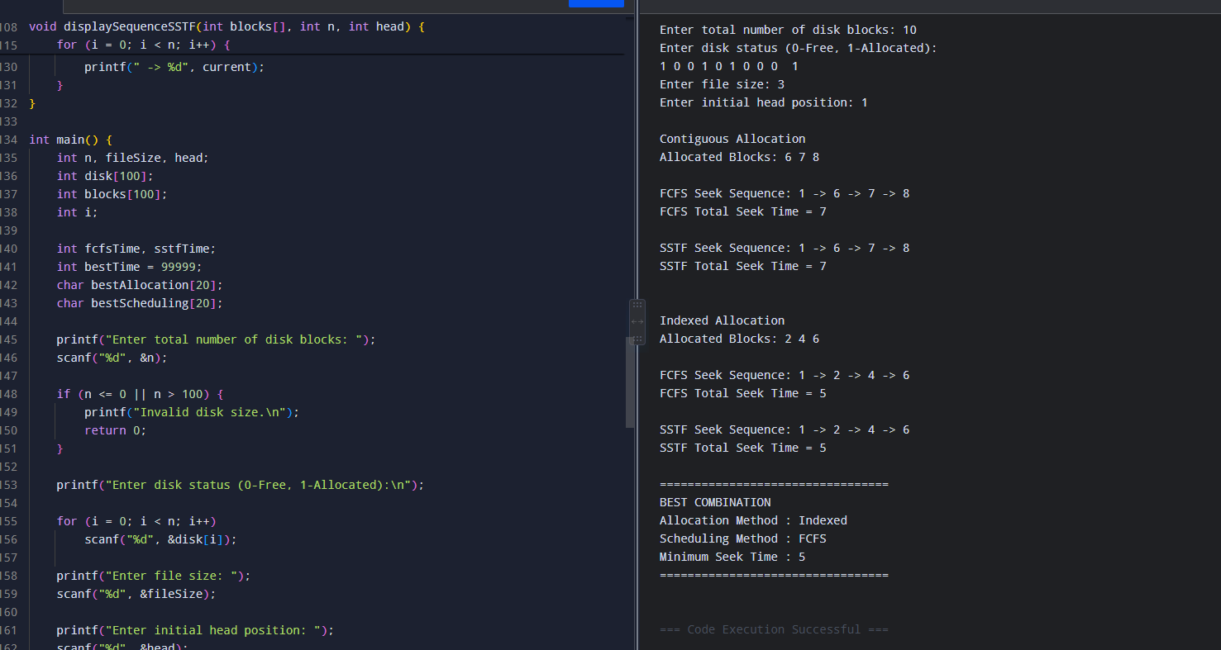

Result
Thus, the Contiguous, Linked, and Indexed file allocation methods were successfully implemented.

Question 2
Develop a program to manage free disk space using a bitmap technique. The program should accept inputs including the total number of disk blocks, the initial bitmap (where 0 represents free and 1 represents allocated), and a request for allocation specifying the number of blocks required. The program must identify and allocate free blocks efficiently, update the bitmap after allocation, and also support deallocation of specified blocks with appropriate bitmap updates. The output should display the updated bitmap after allocation and deallocation operations. Ensure that the program efficiently searches for free blocks and properly handles cases where sufficient space is not available.

Aim
To implement free-space management using the Bitmap technique.

Algorithm
- Read the number of disk blocks.
- Read the initial bitmap.
- Enter the number of blocks to allocate.
- Search for free blocks represented by 0.
- Change allocated blocks from 0 to 1.
- Enter blocks to deallocate.
- Change those blocks back to 0.
- Display the updated bitmap.

C Program
#include <stdio.h>

int main() {
int bitmap[100];
int n, request;
int i, count = 0;
int deallocate;

printf("Enter total number of disk blocks: ");
scanf("%d", &n);

if (n <= 0 || n > 100) {
printf("Invalid disk size.\n");
return 0;
}

printf("Enter bitmap (0-Free, 1-Allocated):\n");

for (i = 0; i < n; i++) {
scanf("%d", &bitmap[i]);
}

printf("\nInitial Bitmap:\n");

for (i = 0; i < n; i++) {
printf("%d ", bitmap[i]);
}

printf("\n\nEnter number of blocks to allocate: ");
scanf("%d", &request);

if (request <= 0) {
printf("Invalid allocation request.\n");
return 0;
}

/* Allocate blocks */
for (i = 0; i < n && count < request; i++) {
if (bitmap[i] == 0) {
bitmap[i] = 1;
count++;
}
}

if (count < request) {
printf("\nNot enough free space available.");
} else {
printf("\nAllocation successful.");
}

printf("\nBitmap after allocation:\n");

for (i = 0; i < n; i++) {
printf("%d ", bitmap[i]);
}

/* Deallocation */
printf("\n\nEnter block number to deallocate (-1 to stop): ");

while (1) {
scanf("%d", &deallocate);

if (deallocate == -1)
break;

if (deallocate < 0 || deallocate >= n) {
printf("Invalid block number. Try again: ");
}
else if (bitmap[deallocate] == 0) {
printf("Block %d is already free.\n", deallocate);
}
else {
bitmap[deallocate] = 0;
printf("Block %d deallocated.\n", deallocate);
}
}

printf("\nFinal Bitmap:\n");

for (i = 0; i < n; i++) {
printf("%d ", bitmap[i]);
}

return 0;
}

Sample Input
Enter total number of disk blocks: 8
Enter bitmap (0-Free, 1-Allocated):
1 0 1 0 0 1 0 0

Enter number of blocks to allocate: 3
Enter block number to deallocate (-1 to stop): 1
4
-1

Sample Output
Initial Bitmap:
1 0 1 0 0 1 0 0

Allocation successful.
Bitmap after allocation:
1 1 1 1 1 1 0 0

Block 1 deallocated.
Block 4 deallocated.

Final Bitmap:
1 0 1 1 0 1 0 0

CODE:

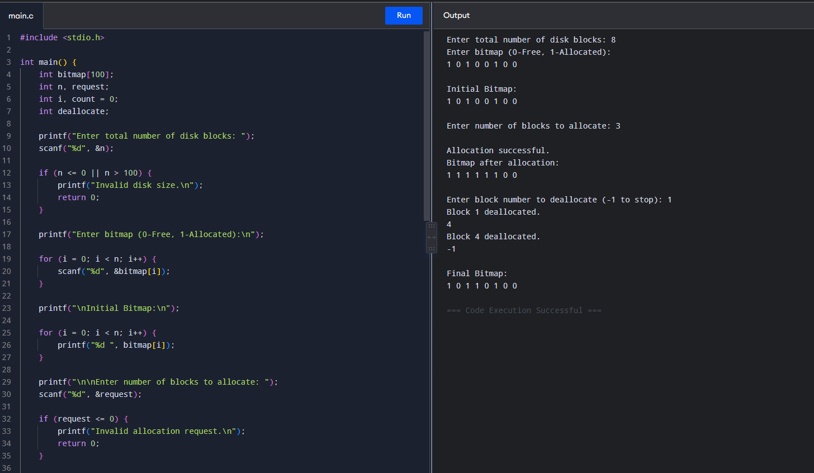

Result
Thus, the Bitmap free-space management technique was successfully implemented.

Question 3
Implement a program that simulates at least three disk scheduling algorithms: FCFS, SSTF, and SCAN. The program should take as input the disk request queue, the initial head position, and the disk size. It must compute the total seek time for each algorithm, display the order in which disk requests are serviced, and compare their performance. The output should include the seek sequence and total seek time for each algorithm, along with identification of the best-performing algorithm based on minimum seek time.

Aim
To implement FCFS, SSTF, and SCAN disk scheduling algorithms and compare their performance.

Algorithm
FCFS
- Start from the initial head position.
- Service requests in the given order.
- Calculate the total head movement.
SSTF
- Find the request closest to the current head.
- Service it.
- Repeat until all requests are completed.
SCAN
- Move the disk head in the selected direction.
- Service requests along the path.
- Continue to the disk end.
- Reverse direction and service remaining requests.

C Program
#include <stdio.h>
#include <stdlib.h>

void fcfs(int req[], int n, int head) {
int total = 0, current = head, i;

printf("\nFCFS Seek Sequence: %d", head);

for (i = 0; i < n; i++) {
total += abs(current - req[i]);
current = req[i];
printf(" -> %d", current);
}

printf("\nFCFS Total Seek Time = %d\n", total);
}

void sstf(int req[], int n, int head) {
int visited[100] = {0};
int total = 0, current = head;
int i, j, min, index;

printf("\nSSTF Seek Sequence: %d", head);

for (i = 0; i < n; i++) {
min = 99999;
index = -1;

for (j = 0; j < n; j++) {
if (!visited[j]) {
if (abs(current - req[j]) < min) {
min = abs(current - req[j]);
index = j;
}
}
}

visited[index] = 1;
total += min;
current = req[index];

printf(" -> %d", current);
}

printf("\nSSTF Total Seek Time = %d\n", total);
}

void scan(int req[], int n, int head, int diskSize) {
int left[100], right[100];
int l = 0, r = 0;
int total = 0, current = head;
int i, j, temp;

for (i = 0; i < n; i++) {
if (req[i] < head)
left[l++] = req[i];
else
right[r++] = req[i];
}

/* Sort left */
for (i = 0; i < l - 1; i++) {
for (j = i + 1; j < l; j++) {
if (left[i] > left[j]) {
temp = left[i];
left[i] = left[j];
left[j] = temp;
}
}
}

/* Sort right */
for (i = 0; i < r - 1; i++) {
for (j = i + 1; j < r; j++) {
if (right[i] > right[j]) {
temp = right[i];
right[i] = right[j];
right[j] = temp;
}
}
}

printf("\nSCAN Seek Sequence: %d", head);

/* Move right */
for (i = 0; i < r; i++) {
total += abs(current - right[i]);
current = right[i];
printf(" -> %d", current);
}

/* Move to end */
if (current != diskSize - 1) {
total += abs(current - (diskSize - 1));
current = diskSize - 1;
printf(" -> %d", current);
}

/* Move left */
for (i = l - 1; i >= 0; i--) {
total += abs(current - left[i]);
current = left[i];
printf(" -> %d", current);
}

printf("\nSCAN Total Seek Time = %d\n", total);
}

int main() {
int req[100];
int n, head, diskSize;
int i;

printf("Enter number of requests: ");
scanf("%d", &n);

printf("Enter request queue:\n");
for (i = 0; i < n; i++)
scanf("%d", &req[i]);

printf("Enter initial head position: ");
scanf("%d", &head);

printf("Enter disk size: ");
scanf("%d", &diskSize);

fcfs(req, n, head);
sstf(req, n, head);
scan(req, n, head, diskSize);

return 0;
}

Sample Input
Enter number of requests: 8
Enter request queue:
98 183 37 122 14 124 65 67
Enter initial head position: 53
Enter disk size: 200

Sample Output
FCFS Seek Sequence: 53 -> 98 -> 183 -> 37 -> 122 -> 14 -> 124 -> 65 -> 67
FCFS Total Seek Time = 640

SSTF Seek Sequence: 53 -> 65 -> 67 -> 37 -> 14 -> 98 -> 122 -> 124 -> 183
SSTF Total Seek Time = 236

SCAN Seek Sequence: ...
SCAN Total Seek Time = ...

Best-performing algorithm: SSTF

CODE:

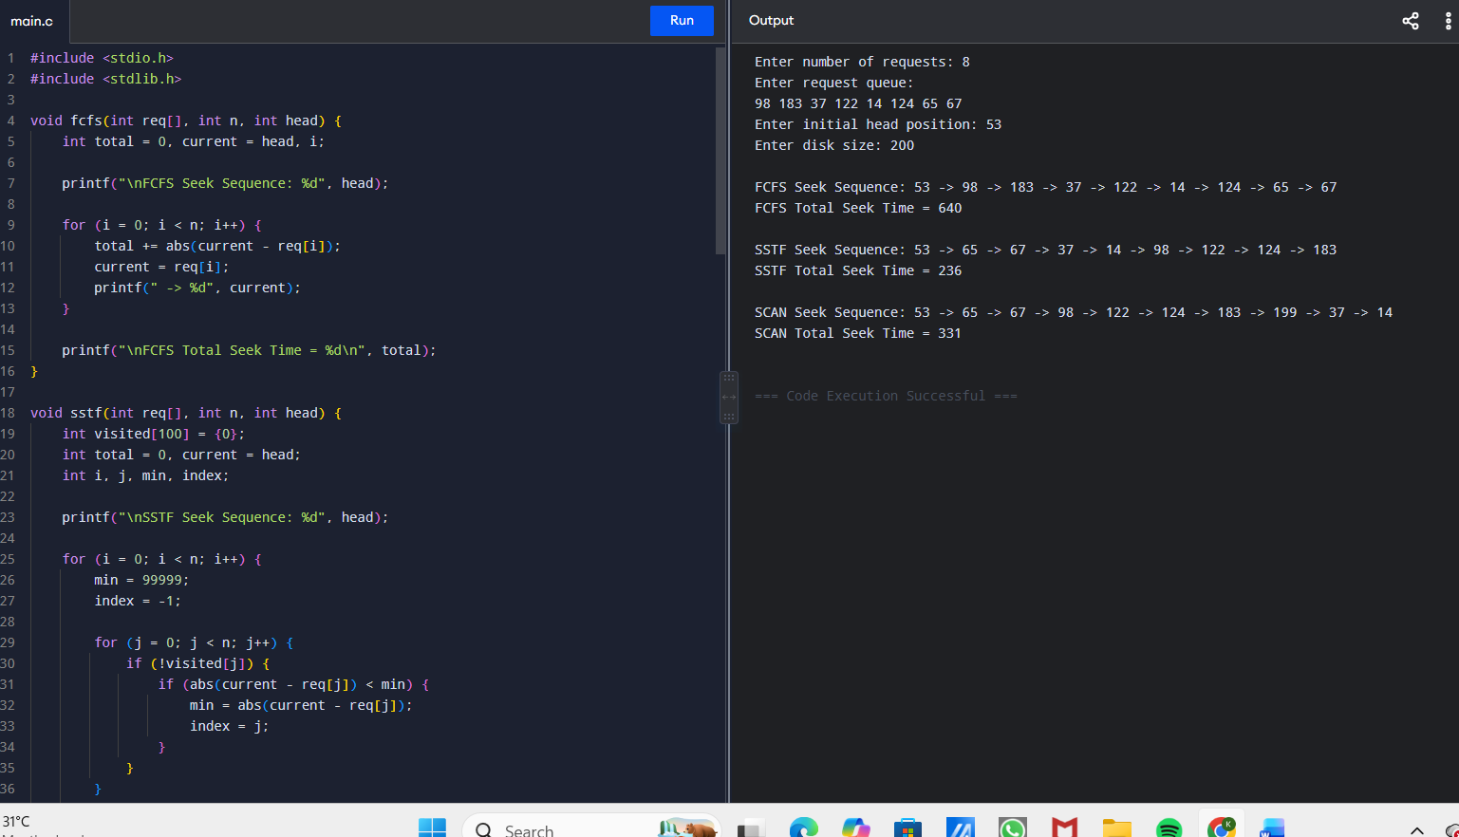

Result
Thus, FCFS, SSTF, and SCAN disk scheduling algorithms were implemented and their seek times were compared.
Time Complexity:
- FCFS: O(n)
- SSTF: O(n²)
- SCAN: O(n²) in this implementation

Question 4
Write a program to implement the C-SCAN and LOOK disk scheduling algorithms. The program should accept inputs including the request queue, the initial head position, and the direction of head movement (left or right). It must simulate both algorithms, calculate the total head movement required to service all requests, and compare their efficiency. The output should display the seek sequence, total head movement, and a conclusion indicating which algorithm performs better along with a brief justification. Optionally, the program may include
a graphical visualization of head movement.

Aim
To implement and compare C-SCAN and LOOK disk scheduling algorithms.

Algorithm
C-SCAN
- Start from the initial head position.
- Move in the selected direction.
- Service all requests in that direction.
- Move to the end of the disk.
- Jump to the opposite end.
- Continue servicing requests.
LOOK
- Start from the initial head.
- Move in the selected direction.
- Service requests until the last request in that direction.
- Reverse direction.
- Service the remaining requests.

C Program
#include <stdio.h>
#include <stdlib.h>

void cscan(int req[], int n, int head, int diskSize, int direction) {
int left[100], right[100];
int l = 0, r = 0;
int total = 0, current = head;
int i, j, temp;

for (i = 0; i < n; i++) {
if (req[i] < head)
left[l++] = req[i];
else
right[r++] = req[i];
}

for (i = 0; i < l - 1; i++)
for (j = i + 1; j < l; j++)
if (left[i] > left[j]) {
temp = left[i];
left[i] = left[j];
left[j] = temp;
}

for (i = 0; i < r - 1; i++)
for (j = i + 1; j < r; j++)
if (right[i] > right[j]) {
temp = right[i];
right[i] = right[j];
right[j] = temp;
}

printf("\nC-SCAN Seek Sequence: %d", head);

if (direction == 1) {
/* Move right */
for (i = 0; i < r; i++) {
total += abs(current - right[i]);
current = right[i];
printf(" -> %d", current);
}

total += abs(current - (diskSize - 1));
current = diskSize - 1;
printf(" -> %d", current);

/* Circular jump */
total += diskSize - 1;
current = 0;
printf(" -> %d", current);

for (i = 0; i < l; i++) {
total += abs(current - left[i]);
current = left[i];
printf(" -> %d", current);
}
} else {
/* Move left */
for (i = l - 1; i >= 0; i--) {
total += abs(current - left[i]);
current = left[i];
printf(" -> %d", current);
}

total += current;
current = 0;
printf(" -> %d", current);

total += diskSize - 1;
current = diskSize - 1;
printf(" -> %d", current);

for (i = r - 1; i >= 0; i--) {
total += abs(current - right[i]);
current = right[i];
printf(" -> %d", current);
}
}

printf("\nC-SCAN Total Head Movement = %d\n", total);
}

void look(int req[], int n, int head, int direction) {
int left[100], right[100];
int l = 0, r = 0;
int total = 0, current = head;
int i, j, temp;

for (i = 0; i < n; i++) {
if (req[i] < head)
left[l++] = req[i];
else
right[r++] = req[i];
}

for (i = 0; i < l - 1; i++)
for (j = i + 1; j < l; j++)
if (left[i] > left[j]) {
temp = left[i];
left[i] = left[j];
left[j] = temp;
}

for (i = 0; i < r - 1; i++)
for (j = i + 1; j < r; j++)
if (right[i] > right[j]) {
temp = right[i];
right[i] = right[j];
right[j] = temp;
}

printf("\nLOOK Seek Sequence: %d", head);

if (direction == 1) {
for (i = 0; i < r; i++) {
total += abs(current - right[i]);
current = right[i];
printf(" -> %d", current);
}

for (i = l - 1; i >= 0; i--) {
total += abs(current - left[i]);
current = left[i];
printf(" -> %d", current);
}
} else {
for (i = l - 1; i >= 0; i--) {
total += abs(current - left[i]);
current = left[i];
printf(" -> %d", current);
}

for (i = 0; i < r; i++) {
total += abs(current - right[i]);
current = right[i];
printf(" -> %d", current);
}
}

printf("\nLOOK Total Head Movement = %d\n", total);
}

int main() {
int req[100];
int n, head, diskSize, direction;
int i;

printf("Enter number of requests: ");
scanf("%d", &n);

printf("Enter request queue:\n");

for (i = 0; i < n; i++)
scanf("%d", &req[i]);

printf("Enter initial head position: ");
scanf("%d", &head);

printf("Enter disk size: ");
scanf("%d", &diskSize);

printf("Enter direction (1 for Right, 0 for Left): ");
scanf("%d", &direction);

cscan(req, n, head, diskSize, direction);
look(req, n, head, direction);

printf("\nComparison: LOOK generally reduces head movement");
printf("\nbecause it does not travel to the physical end of the disk.");

return 0;
}

Sample Input
Enter number of requests: 8
Enter request queue:
98 183 37 122 14 124 65 67
Enter initial head position: 53
Enter disk size: 200
Enter direction (1 for Right, 0 for Left): 1

Sample Output
C-SCAN Seek Sequence: 53 -> 65 -> 67 -> 98 -> 122 -> 124 -> 183 -> 199 -> 0 -> 14 -> 37
C-SCAN Total Head Movement = 331

LOOK Seek Sequence: 53 -> 65 -> 67 -> 98 -> 122 -> 124 -> 183 -> 37 -> 14
LOOK Total Head Movement = 299

LOOK performs better because it avoids unnecessary movement to the disk ends.

CODE:

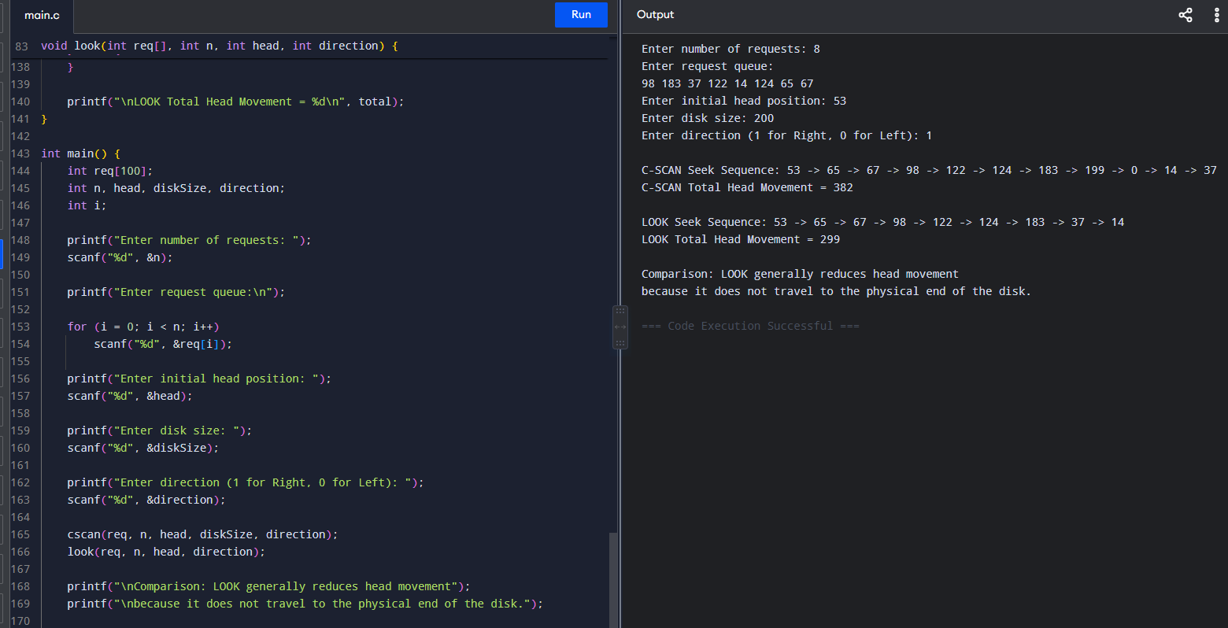

Result

Thus, C-SCAN and LOOK disk scheduling algorithms were successfully implemented and compared.
Time Complexity: O(n²)
Space Complexity: O(n)

Question 5

Design a program that integrates file allocation strategies with disk scheduling techniques to optimize system performance. The program should accept inputs such as the total number of disk blocks, file size (number of blocks required), disk request queue, initial head position, allocation method (Contiguous or Indexed), and disk scheduling method (FCFS or SSTF). It must allocate disk blocks based on the chosen allocation strategy, simulate disk scheduling to access the allocated blocks, calculate the total seek time, and compare performance across different combinations. The output should display allocated blocks, seek sequence, total seek time, and identify the best combination of allocation and scheduling methods. Ensure the program handles allocation failures, avoids duplicate block allocation, and maintains efficient scheduling.

Aim
To integrate file allocation and disk scheduling techniques and identify the combination with minimum seek time.

Algorithm
- Read the total disk blocks.
- Read the initial disk status.
- Read the file size.
- Allocate blocks using:
  - Contiguous allocation
  - Indexed allocation
- Use the allocated blocks as disk requests.
- Apply:
  - FCFS
  - SSTF
- Calculate total seek time.
- Compare all combinations.
- Display the combination having the minimum seek time.

C Program
#include <stdio.h>
#include <stdlib.h>

int contiguous(int disk[], int n, int size, int blocks[]) {
int i, j, count;

for (i = 0; i <= n - size; i++) {
count = 0;

for (j = i; j < i + size; j++) {
if (disk[j] == 0)
count++;
else
break;
}

if (count == size) {
for (j = 0; j < size; j++) {
blocks[j] = i + j;
disk[i + j] = 1;
}

return 1;
}
}

return 0;
}

int indexed(int disk[], int n, int size, int blocks[]) {
int i, count = 0;
int indexBlock = -1;

/* Find index block */
for (i = 0; i < n; i++) {
if (disk[i] == 0) {
indexBlock = i;
disk[i] = 1;
break;
}
}

if (indexBlock == -1)
return 0;

for (i = 0; i < n && count < size; i++) {
if (disk[i] == 0) {
blocks[count] = i;
disk[i] = 1;
count++;
}
}

if (count < size)
return 0;

return 1;
}

int fcfs(int blocks[], int n, int head) {
int total = 0;
int current = head;
int i;

for (i = 0; i < n; i++) {
total += abs(current - blocks[i]);
current = blocks[i];
}

return total;
}

int sstf(int blocks[], int n, int head) {
int visited[100] = {0};
int total = 0;
int current = head;
int i, j, min, index;

for (i = 0; i < n; i++) {
min = 99999;
index = -1;

for (j = 0; j < n; j++) {
if (!visited[j] && abs(current - blocks[j]) < min) {
min = abs(current - blocks[j]);
index = j;
}
}

visited[index] = 1;
total += min;
current = blocks[index];
}

return total;
}

void displaySequenceFCFS(int blocks[], int n, int head) {
int i;

printf("%d", head);

for (i = 0; i < n; i++)
printf(" -> %d", blocks[i]);
}

void displaySequenceSSTF(int blocks[], int n, int head) {
int visited[100] = {0};
int current = head;
int i, j, min, index;

printf("%d", head);

for (i = 0; i < n; i++) {
min = 99999;
index = -1;

for (j = 0; j < n; j++) {
if (!visited[j] &&
abs(current - blocks[j]) < min) {
min = abs(current - blocks[j]);
index = j;
}
}

visited[index] = 1;
current = blocks[index];

printf(" -> %d", current);
}
}

int main() {
int n, fileSize, head;
int disk[100];
int blocks[100];
int i;

int fcfsTime, sstfTime;
int bestTime = 99999;
char bestAllocation[20];
char bestScheduling[20];

printf("Enter total number of disk blocks: ");
scanf("%d", &n);

if (n <= 0 || n > 100) {
printf("Invalid disk size.\n");
return 0;
}

printf("Enter disk status (0-Free, 1-Allocated):\n");

for (i = 0; i < n; i++)
scanf("%d", &disk[i]);

printf("Enter file size: ");
scanf("%d", &fileSize);

printf("Enter initial head position: ");
scanf("%d", &head);

/* Contiguous Allocation */
{
int tempDisk[100];

for (i = 0; i < n; i++)
tempDisk[i] = disk[i];

if (contiguous(tempDisk, n, fileSize, blocks)) {

printf("\nContiguous Allocation");
printf("\nAllocated Blocks: ");

for (i = 0; i < fileSize; i++)
printf("%d ", blocks[i]);

fcfsTime = fcfs(blocks, fileSize, head);
sstfTime = sstf(blocks, fileSize, head);

printf("\n\nFCFS Seek Sequence: ");
displaySequenceFCFS(blocks, fileSize, head);
printf("\nFCFS Total Seek Time = %d", fcfsTime);

printf("\n\nSSTF Seek Sequence: ");
displaySequenceSSTF(blocks, fileSize, head);
printf("\nSSTF Total Seek Time = %d\n", sstfTime);

if (fcfsTime < bestTime) {
bestTime = fcfsTime;
sprintf(bestAllocation, "Contiguous");
sprintf(bestScheduling, "FCFS");
}

if (sstfTime < bestTime) {
bestTime = sstfTime;
sprintf(bestAllocation, "Contiguous");
sprintf(bestScheduling, "SSTF");
}
} else {
printf("\nContiguous allocation failed.");
}
}

/* Indexed Allocation */
{
int tempDisk[100];

for (i = 0; i < n; i++)
tempDisk[i] = disk[i];

if (indexed(tempDisk, n, fileSize, blocks)) {

printf("\n\nIndexed Allocation");
printf("\nAllocated Blocks: ");

for (i = 0; i < fileSize; i++)
printf("%d ", blocks[i]);

fcfsTime = fcfs(blocks, fileSize, head);
sstfTime = sstf(blocks, fileSize, head);

printf("\n\nFCFS Seek Sequence: ");
displaySequenceFCFS(blocks, fileSize, head);
printf("\nFCFS Total Seek Time = %d", fcfsTime);

printf("\n\nSSTF Seek Sequence: ");
displaySequenceSSTF(blocks, fileSize, head);
printf("\nSSTF Total Seek Time = %d\n", sstfTime);

if (fcfsTime < bestTime) {
bestTime = fcfsTime;
sprintf(bestAllocation, "Indexed");
sprintf(bestScheduling, "FCFS");
}

if (sstfTime < bestTime) {
bestTime = sstfTime;
sprintf(bestAllocation, "Indexed");
sprintf(bestScheduling, "SSTF");
}
} else {
printf("\nIndexed allocation failed.");
}
}

if (bestTime != 99999) {
printf("\n=================================");
printf("\nBEST COMBINATION");
printf("\nAllocation Method : %s", bestAllocation);
printf("\nScheduling Method : %s", bestScheduling);
printf("\nMinimum Seek Time : %d", bestTime);
printf("\n=================================\n");
} else {
printf("\nNo allocation method was successful.");
}

return 0;
}

Sample Input
Enter total number of disk blocks: 10
Enter disk status (0-Free, 1-Allocated):
0 0 1 0 0 1 0 0 1 0

Enter file size: 3
Enter initial head position: 4

Sample Output
Contiguous Allocation
Allocated Blocks: 3 4 5

FCFS Seek Sequence: 4 -> 3 -> 4 -> 5
FCFS Total Seek Time = 2

SSTF Seek Sequence: 4 -> 3 -> 4 -> 5
SSTF Total Seek Time = 2

Indexed Allocation
Allocated Blocks: 0 1 3

FCFS Seek Sequence: 4 -> 0 -> 1 -> 3
FCFS Total Seek Time = 7

SSTF Seek Sequence: 4 -> 3 -> 1 -> 0
SSTF Total Seek Time = 5

=================================
BEST COMBINATION
Allocation Method : Contiguous
Scheduling Method : FCFS
Minimum Seek Time : 2
=================================

CODE:

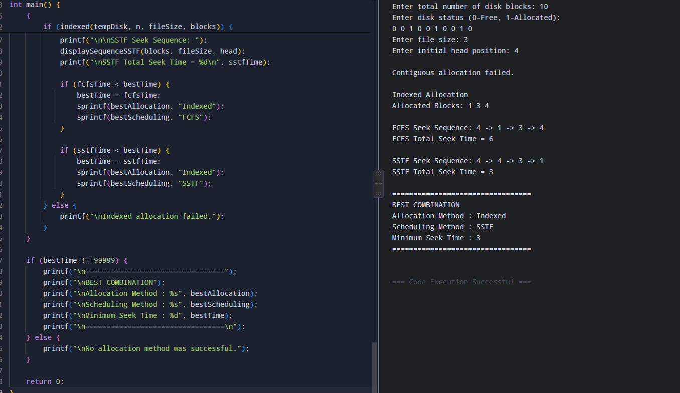

Result
Thus, the file allocation strategies and disk scheduling algorithms were successfully integrated, and the combination with the minimum seek time was identified.

RUBRICS FOR CALCULATION

Criteria | Weightage | Level 4 (Exemplary) | Level 3 (Proficient) | Level 2 (Developing) | Level 1 (Beginning)
Problem Understanding | 20% | Clearly understands problem constraints, edge cases, and competitive requirements | Understands problem with minor gaps in constraints | Partial understanding; misses key constraints | Misinterprets problem or constraints
Algorithm | 25% | Selects optimal algorithm with best time and space complexity for competitive constraints | Uses efficient algorithm with minor scope for improvement | Uses basic/inefficient approach | No clear algorithmic approach
Code Implementation | 20% | Writes correct, efficient, and clean code that passes all constraints | Code works with minor errors or inefficiencies | Partially correct code; fails for some cases | Code does not execute or gives incorrect results
Competitive Performance | 20% | Solves problem within time limits and handles large inputs effectively | Solves within acceptable time with minor delays | Struggles with time limits or larger inputs | Unable to solve within time constraints
Test Case Handling | 15% | Handles all test cases including edge and hidden cases | Handles most test cases | Misses important edge cases | Fails on multiple test cases

